**Question 1**:

Wrap this poem around such HTML tags that will preserve all spaces and line-breaks when the element is displayed.

|  |
| --- |
| <poem>  The sun has set, the day is done,    The stars appear, one by one.    A gentle breeze begins to blow,    As night unfolds its peaceful glow.        The moonlight dances on the lake,    Reflecting dreams that softly wake.    In this quiet, tranquil place,    I find my heart’s most sacred space.  </poem> |

**Question 2**:

Fix the following form code to ensure it captures user information correctly.

|  |
| --- |
| <form action="/submit">  <name>Full Name:</name>  <input type="text" name="fullname">    <email>Email:</email>  <input type="email" name="email">    <submit>Submit</submit>  </form> |

**Question 3**:

This is the desired output, but the code has some error(s). Find out.

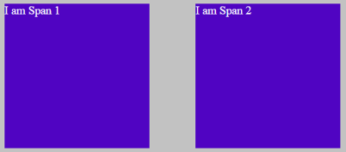

Given:



|  |
| --- |
| <!DOCTYPE html>  <html lang="en">    <head>  <meta charset="UTF-8" />  <meta http-equiv="X-UA-Compatible" content="IE=edge" />  <meta name="viewport" content="width=device-width, initial-scale=1.0" />  <title>Document</title>  <style>  body {  background-color: rgba(128, 128, 128, 0.479);  }    .box {  height: 200px;  width: 200px;  margin: 30px;  color: rgb(255, 255, 255);  background-color: rgb(80, 4, 194);  }  </style>  </head>    <body>  <span class="box">I am Span 1</span>  <span class="box">I am Span 2</span>  </body>    </html> |

**Question 4**:

Try to find the bugs in the code and correct the code to match the UI given below.

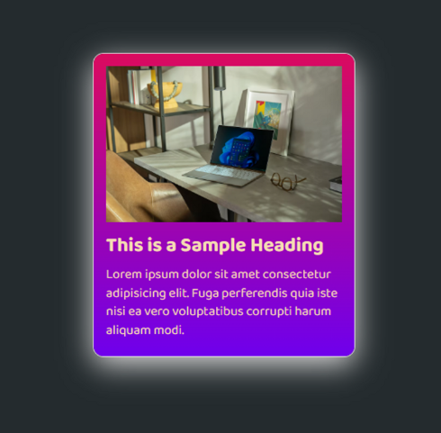

|  |
| --- |
| <!DOCTYPE html>  <html lang="en">    <head>  <meta charset="UTF-8" />  <meta http-equiv="X-UA-Compatible" content="IE=edge" />  <meta name="viewport" content="width=device-width, initial-scale=1.0" />  <title>Document</title>    <style>  @import url("https://fonts.googleapis.com/css2?family=Baloo+Bhai+2:wght@400;500;700&display=swap");    * {  margin: 0;  padding: 0;  }    body {  height: 100rme;  background-color: #242b2e;  }    .container {  margin: 20vh;  width: 21vw;  padding: 15px;  border-radius: 12px;  background-color: linear-gradient(#db0b5f, 45degree, #6f00ed);  color: wheat;  shadow: #e2e1e1 0px 10px 36px 0px, #e2e1e1 0px 0px 0px 1px;  }    h2 {  font-family: "Baloo Bhai 2", cursive;  font-weight: 700;  font-weight: bold;  margin: 5px 0px;  }    .text {  margin: 5px 0px;  font-family: "Baloo Bhai 2", cursive;  font-weight: 400;  line-height: 1.4em;  }  </style>  </head>    <body>  <div class="container">  <img src="https://images.unsplash.com/photo-1661961112835-ca6f5811d2af?ixlib=rb-4.0.3&ixid=MnwxMjA3fDF8MHxwaG90by1wYWdlfHx8fGVufDB8fHx8&auto=format&fit=crop&w=872&q=80"  alt="" />  <div></div>  <h2>This is a Sample Heading</h2>  <div class="text">  Lorem ipsum dolor sit amet consectetur adipisicing elit. Fuga  perferendis quia iste nisi ea vero voluptatibus corrupti harum aliquam  modi.  </div>  </div>  </body>    </html> |

**Question 5**:

Figure out the CSS issues in the existing code to achieve a card like this.

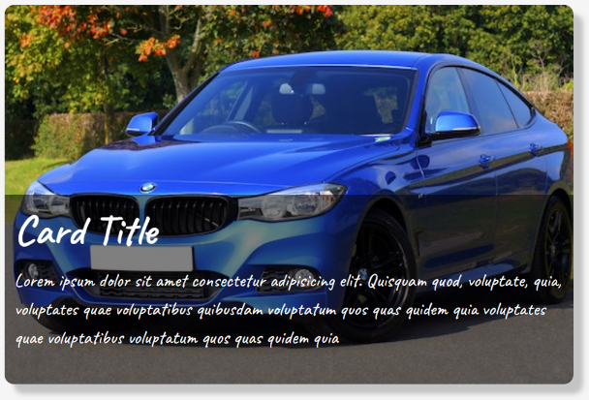

|  |
| --- |
| <!DOCTYPE html>  <html lang="en">    <head>  <meta charset="UTF-8" />  <meta http-equiv="X-UA-Compatible" content="IE=edge" />  <meta name="viewport" content="width=device-width, initial-scale=1.0" />  <title>Document</title>    <style>  @import url("https://fonts.googleapis.com/css2?family=Caveat:wght@400;500;600&display=swap");    * {  margin: 0;  padding: 0;  box-sizing: border-box;  }    body {  background-color: #f5f5f5;  }    .container {  width: 50%;  height: 100vw;  display: flex;  justify-items: center;  align-content: center;  }    .card {  width: 600px;  height: 400px;  background-color: #fff;  border-radius: 10px;  box-shadow: 10px 10px 5px rgba(0, 0, 0, 0.2);  position: relative;  }    .card img {  width: 100%;  height: 100%;  object-fit: cover;  }    .caption {  position: relative;  bottom: 0;  left: 0;  width: 100%;  height: 50%;  background-color: rgba(0, 0, 0, 0.5);  padding: 10px;  color: #fff;  }    .caption h3 {  font-size: 2.75rem;  margin-bottom: 10px;  }    .caption p {  font-size: 1.25rem;  line-height: 1.5;  }  </style>  </head>    <body>  <main class="contianer">  <div class="card">  <img  src="https://images.pexels.com/photos/170811/pexels-photo-170811.jpeg?cs=srgb&dl=pexels-mike-b-170811.jpg&fm=jpg&w=640&h=360"  alt="car image" />  <div class="caption">  <h2>Card Title</h2>  <p>  Lorem ipsum dolor sit amet consectetur adipisicing elit. Quisquam quod, voluptate, quia, voluptates quae  voluptatibus quibusdam voluptatum quos quas quidem quia voluptates quae voluptatibus voluptatum quos quas  quidem quia  </p>  </div>  </div>  </main>  </body>    </html> |

**Question 6**:

Try to find the bugs in the code and correct the code to match the UI given below.

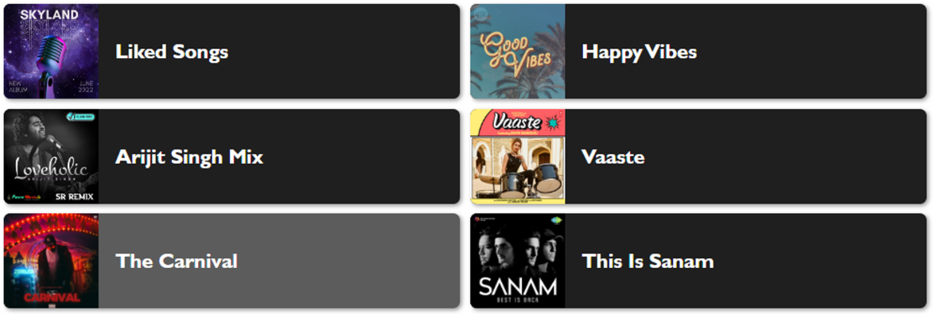

|  |
| --- |
| <!DOCTYPE html>  <html lang="en">    <head>  <meta charset="UTF-8" />  <meta http-equiv="X-UA-Compatible" content="IE=edge" />  <meta name="viewport" content="width=device-width, initial-scale=1.0" />  <title>Document</title>  </head>  <style>  .container {  max-width: 1200px;  margin: 0 auto;  display: flex;  gap: 12px;  }    .music-card {  width: 50%;  display: block;  height: 7hv;  background-Color: #1f1f1f;  color: white;  font-family: "Gill Sans" "Gill Sans MT" Calibri, "Trebuchet MS",  sans-serif;  gap: 20px;  border-radius: 8px transition: any 0.3sec;  shadw: 2px 2px 5px #606060a9;  }    .music-card:hover {  backGround: #1f1f1fb9;  }    .music-card img {  border-radius: 8px;  }  </style>    <body>  <div class="container">  <div class="music-card">  <img src="https://static-cse.canva.com/blob/978202/1600w-YmFtIRl8-qo.jpg" alt="" />  <h2>Liked Songs</h2>  </div>  <div class="music-card">  <img src="https://cdn.musicvine.com/images/good-vibes-collection-cover-v2_5528980777329875.jpg" alt="" />  <h2>Happy Vibes</h2>  </div>  <div class="music-card">  <img  src="https://powermusic.in/folderthumb/924122782217-Arijit%20Singh%20Hindi%20Love%20New%20Style%20Humbing%202022%20-%20Dj%20SR%20Remix.jpg"  alt="" />  <h2>Arijit Singh Mix</h2>  </div>  <div class="music-card">  <img src="https://i.scdn.co/image/ab67616d00001e028dce351c5e4a62c2ea2dd498" alt="" />  <h2>Vaaste</h2>  </div>  <div class="music-card">  <img src="https://a10.gaanacdn.com/images/albums/93/3398093/crop_480x480_3398093.jpg" alt="" />  <h2>The Carnival</h2>  </div>  <div class="music-card">  <img src="https://c.saavncdn.com/735/Sanam-Best-Is-Back-Hindi-2016-500x500.jpg" alt="" />  <h2>This Is Sanam</h2>  </div>  </div>  </body>    </html> |